Vehicle Emergency Evacuation Procedures

Page 1 of 2

If you are involved in any type vehicle incident that requires the immediate evacuation of passengers you must adhere to the following procedures to ensure the safety of those passengers are central to your evacuation.

Vehicle Fire

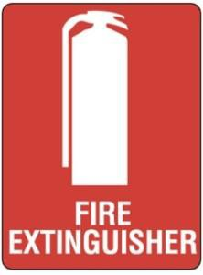

- Pull vehicle over immediately to the near side lane/kerb ensuring that it is safe and out of danger from other road users, trees and buildings.
- Open all doors and SHUT down engine as soon as practicable. If vehicle is fitted with master isolator switch then this must be switched off.
- Instruct passengers to disembark in an orderly and safe manner and move away to the side to a safe location.
- Access vehicle fire extinguisher and attempt to contain fire (if the fire is contained to the engine bay, you must NEVER open the engine hatch to attempt to extinguish fire).
- If access to exit doors is restricted due to fire, then instruct a responsible person to utilise emergency window hammers to break emergency windows to allow access from the side of the vehicle.
- Check the welfare of your passengers and assess any injuries.
- Contact Emergency Services on “000” to seek assistance.
- Contact Crown Coaches Operations to notify of incident and seek guidance.

Vehicle Accident

- Pull vehicle over immediately to the near side lane/kerb ensuring that it is safe and out of danger from other road users.
- Check the welfare of your passengers and assess any injuries.
- Instruct passengers to disembark in an orderly and safe manner and move away to the side to a safe location.
- 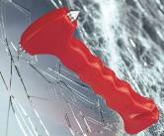If access to exit doors is restricted due to vehicle damage, then instruct a responsible person to utilise emergency window hammers to break emergency windows to allow access from the side of the vehicle.

- Check the welfare of your passengers and assess any injuries.
- Contact Emergency Services on “000” to seek assistance.
- Contact Crown Operations to notify of incident and seek guidance.

