Evacuation of Accessible Passengers

Accessibility is the degree to which a product, device, service or environment is available to as many people as possible. Accessibility can be viewed as the "ability to access" and benefit from some system or entity. The concept often focuses on people with disabilities or special needs and their right of access, enabling the use of assistive technology.

If you are involved in any type of vehicle incident that requires the immediate evacuation of accessible passengers, you must adhere to the following procedures to ensure the safety of those passengers are central to your evacuation.

Extreme Emergency Evacuation

Extreme Emergency Evacuation

Emergency evacuation is the immediate and rapid movement of people away from the threat or actual occurrence of a hazard. Examples range from vehicle fire, vehicle accident, evacuation due to a bomb treat, to the large scale evacuation of a district because of a flood, bombardment or approaching weather system.

In an event of an incident where all passengers must be evacuated, the accessible passenger/s must only be removed if it is more dangerous to leave the passenger/s on the vehicle.

The driver must evacuate all accessible passenger/s using the following methods (in order of preference):

- Use the wheel chair hoist as per normal operation;
- Use the emergency ramp (if fitted);
- Lift the wheel chair passenger (while still in the chair) with the help of others available and carry off the vehicle via the exit door. You must always carry the wheel chair backwards;
- Lift the passenger (without the chair) with help of others available and carry off the vehicle via the exit door. You must always carry the passenger backwards;
- Lift the accessible passenger, with the help of others available and evacuate via an emergency window (use emergency hammer to break window).

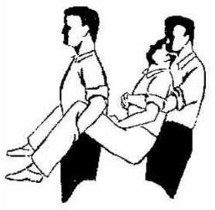

Accessible passenger evacuation with no help available

In the event a driver is alone and unable to engage the help of others, the evacuation of an accessible passenger is best accomplished by:

- Checking with the passenger for the best way to carry him/her and proceeding accordingly;
- If the passenger is unconscious, the best technique to use is the “Fireman’s Carry”. This technique if done properly, will enable to you move a passenger who may be larger than you while ensuring the lift does not cause any injury to the lifter.

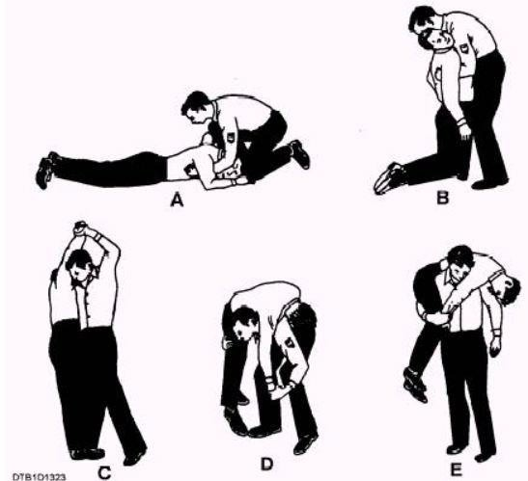

How to do a Fireman’s Carry

- Lift the injured or unconscious person into a standing position. Squat down in front of him, grasp him under the arms and lift him against your own body and raise to a standing position so that you are now both on your feet face to face;
- Support the person around the waist with one hand and raise her arm closest to you with the other hand. Raise the arm until it is fully extended over your head;
- Maintain your hold on the person's lifted arm and bend at the knees and slightly forward. Allow the person to fall across your shoulders;
- Return to a standing position. Use your legs and not your back to stand and support the person's weight across your back;
- Hold the person during a fireman carry by wrapping one arm around the backs of his knees and holding his arm down across the front of your body.

Tips and Warnings

- Always lift with your legs and not with your back to avoid injury;
- Be sure to support the person across both shoulders and not just over one shoulder. A true fireman carry uses both shoulders to transport an injured or unconscious person.

Vehicle Accident

- If there is no imminent danger resulting from the accident, accessible passengers must remain on board until such time as the vehicle can continue on, or a replacement vehicle is available;
- If there has been injuries sustained, wheel chair passengers must remain on board until Emergency Services have arrived and administered first aid as required. Passengers are only to be removed under instruction from Emergency Services.

Vehicle Wheel Chair hoist breakdown

- Follow procedure in Company handbook and switch controls on hoist from automatic to manual and operate hoist manually to unload wheel chairs.
- If the manual operation is not available then exiting the vehicle via the emergency ramp at the rear/side of the vehicle is required (where fitted);
- If the vehicle is not fitted with an emergency ramp then the wheel chair passengers must remain on board until the hoist has been repaired or until the next accessible vehicle becomes available and a vehicle to vehicle passenger transfer can occur (vehicle to vehicle transfer is possible by aligning both wheel chair access doors and transferring passengers across to replacement vehicle).

Emergency Evacuation Summarisation

- Use lift;
- Use emergency ramp;
- Lift wheel chair through doors;
- Lift passenger through doors;
- Lift passenger through window;
- Carry passenger off using fireman’s carry.

