DRIVER BUS FAMILIARISATION FOR A SPECIFIC BUS TYPE

Section from Sample Driver Training Document Dash, Emergency Communications, Warning Systems and Emergency Exit Locations Courtesy of State Transit

Mercedes-Benz OC 500 LE 1825h CNG City Bus - Custom Coaches CB60 Body

Emergency Alarm Radio Buttons
There are three emergency radio buttons. One is located under the footrest to the left of the steering column. To access the foot switch, lift the metal plate with the toe of your shoe then press the switch with your foot for three seconds
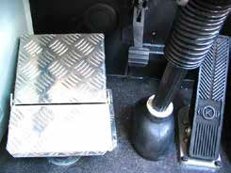

The second switch is located to the left of the driver’s seat on the panel behind the driver’s cabin door.
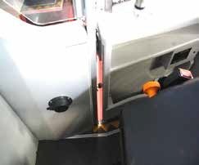

Figure 2-1 Emergency alarm under flip-up foot rest

Figure 2-2 Emergency alarm on left hand side of driver
Hold any button down for three seconds to activate the system.
DO NOT ACTIVATE THESE ALARMS UNLESS IN AN EMERGENCY
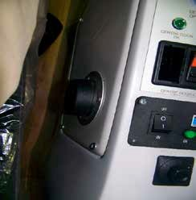

Figure 2-3 emergency alarm of right- hand side of driver

The third button is located to the right of the driver’s seat

Location of Emergency Door Open Switches
Emergency door open switches are located inside the bus and outside the bus to allow passengers and rescuers to open the doors in an emergency where the driver is unable to operate the doors.
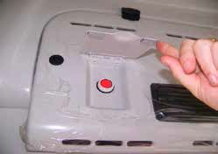

Inside the bus, these buttons are located in the panel above the door lintel as shown and are activated by lifting the flap and pressing the red button.

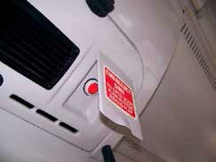

Figure 2-4 Emergency door open button front door - internal
Figure 2-5 Emergency door open button rear door - internal

Outside the bus, the emergency open buttons are located at the base of the rearmost pillar of each doorway.
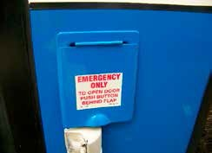

Figure 2-7 Emergency door open button front door - external
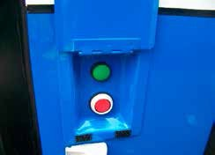

Figure 2-6 Emergency door open button rear door - external

With the flap lifted, the red button opens the door and the green button closes the door.

Location of Fire Extinguisher

The fire extinguisher is a 4.5kg dry chemical extinguisher suitable for all fire types. It is located outside of the driver’s cabin just forward of the driver’s door.

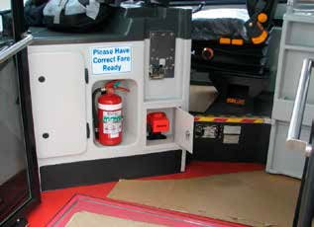





Fire Extinguisher
Jump Start Plug behind flap

Figure 2-8 Location of fire extinguisher and jump start plug

Location of Emergency Exits

Emergency Exits – Side Windows

In case of an emergency where the front door and centre door may be blocked or restricted, there are two window emergency exits in the vicinity of the wheelchair spaces; one on the left hand side, one on the right hand side. Emergency break glass hammers are used to smash the safety glass and are located near the windows on the interior cant panel above the window. If the hammer is removed from its holder, an alarm sounds and a warning light illuminates in the driver’s cab.

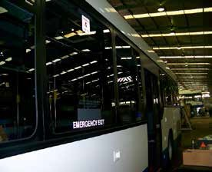

Figure 2-10 Emergency exit window is smashed to allow escape/entry
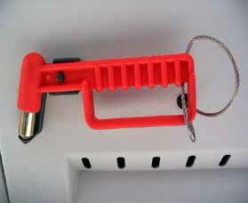

2-9 Hammer to Break Window emergency Exit

Emergency Exits – Roof Hatches

There are also two exits through the roof hatches but these are used mainly for the situation where the bus may be lying on its side or if the bus is sandwiched by obstructions on either side. Familiarise yourself with the operation of the roof hatch.

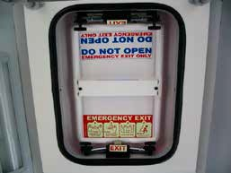
Figure 2-11 Roof Hatch Emergency Exit

Location of Emergency Stop / Master Isolation Switch

The emergency stop switch is located on the console to the right hand side as shown in the figure below. This switch will turn the engine off and cut off the electrical power supply to the body. This is also to be activated when securing the bus. NEVER ACTIVATE THIS SWITCH WHILE THE BUS IS IN MOTIION.

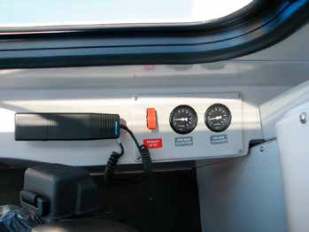



Emergency Stop / Isolation
Figure 2-12 Location of Emergency Stop / Isolation Switch

2 Instruments and Warning Lights

2.1 Indication Display Unit

2.1.1Layout
The indication display unit is shown in figure below:

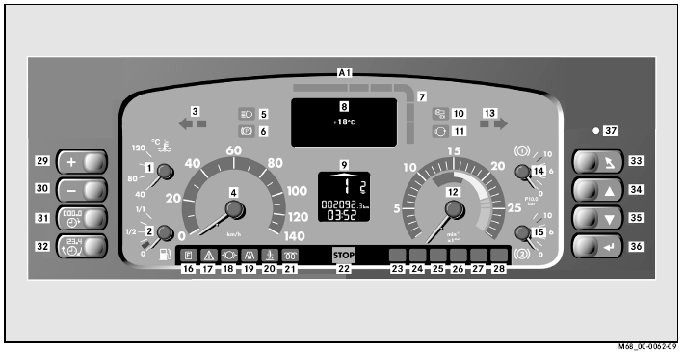
Figure 2-1 Indication Display Unit

1 | Coolant Temperature | 20 | Not used
2 | Not used | 21 | Not used
3 | Turn indicator left /hazard warning | 22 | STOP Red warning lamp
4 | Road speed display | 23 | Not used
5 | High beam indicator light | 24 | Not used
6 | Parking brake indicator | 25 | Not used
7 | Red/Yellow fault lamp | 26 | Not used
8 | Driver information (FIS) display | 27 | Not used
9 | Multi function display (MFD) | 28 | Not used
10 | Door/brake interlock indicator lamp | 29 | Adjust clock/ increase instrument lighting
 |  |  | brightness
11 | Not used | 30 | Adjust clock/ decrease instrument lighting
 |  |  | brightness
12 | Engine speed display (Tachometer.) | 31 | Reset trip meter to “0” /Adjust clock/Store
13 | Turn indicator right /hazard warning | 32 | Show trip meter or clock
14 | Reservoir pressure brake circuit 1 | 33 | Menu / Exit
 | display(Front)
15 | Reservoir pressure brake circuit 2 | 34 | Move up menu
 | display(Rear)
16 | Not Used | 35 | Move down menu
17 | Not Used | 36 | Enter/Select
18 | Not used | 37 | Not Used
19 | Not used | 38

2.1.2Features

Lamp test on start-up
After the engine is switched on the instrument panel tests all assigned indicator lamps by illuminating for approximately ten seconds.

Parking brake indicator lamp

The parking brake indicator lamp(6) lights up when the parking brake is applied
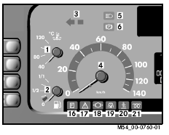

Door interlock indicator lamp

The door interlock indicator lamp(10) lights up when the a door is opened.
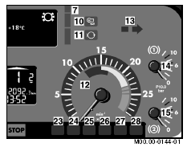

STOP red warning lamp

The Stop red warning lamp (22) lights up when a serious fault is detected on the bus and the operational reliability and or roadworthiness of the bus is endangered. This may be due to:
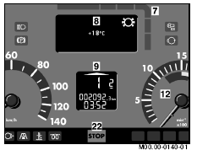

        - Engine oil pressure too low
        - Air system pressure too low.

If the STOP red warning light is illuminated, stop the bus immediately depending on traffic conditions and switch off the engine.

Adjust Instrument Lighting

The brightness of the instrument lighting can be infinitely adjusted. With the ignition on, press and hold button [ + ] , (1) to increase brightness, or button [ - ] , (2) to decrease brightness.
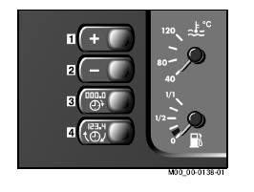

Multifunction display
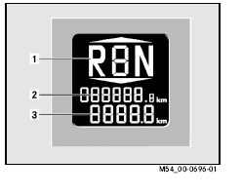

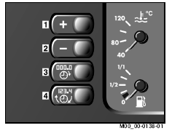

The information below is displayed to the driver:

      - Gear display(1)
      - Total distance travelled (2)
      - Trip or time meter (3)

Displaying the trip meter or time
Press button (4). The display changes from time to trip meter..The time will always be displayed after the ignition is switched on.

Setting the trip meter to zero
Press button (3) with trip meter displayed in MFD

Setting the time
Press button (3), and the hours currently set flash. To adjust the hours, press button (1) or (2). Press button (3) again. The minutes currently set flash. To adjust the minutes press buttons (1) or (2).

Driver information system (FIS) display

Operating information and warnings are automatically displayed to the driver in the FIS display (8) and the status indicator (7).
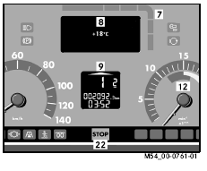

Symbols are used to show the vehicle’s operating state on the FIS display. Several items of information can be shown simultaneously

Status indicator Warnings

When the status indicator (7) lights up yellow it is permissible to continue to drive the bus with care, but the cause of the warning must be rectified as soon as it is possible. NOTE: IF THE FAULT IS A BRAKING SYSTEM FAULT, DESIGNATED BY “BS” IN THE TOP LEFT-HAND SQUARE AT (1),
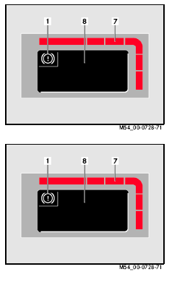

THE BUS DRIVING AND BRAKING BEHAVIOUR MAY CHANGE AND THE DOOR/BRAKE INTERLOCK FUNCTION MAY NOT OPERATE.

When the status indicator (7) lights up red the bus must be stopped immediately if traffic conditions allow and maintenance staff notified.
A warning buzzer in the instrument panel alerts the driver to the red indicator status.
NOTE: IF THE FAULT IS A BRAKING SYSTEM FAULT, DESIGNATED BY “BS” IN THE TOP LEFT-HAND SQUARE AT (1), THE BUS BRAKING BEHAVIOUR CHANGES AND BRAKE PEDAL TRAVEL/FEEL CAN CHANGE.

All current warnings and operating information are shown in succession in the FIS display. The display changes every five seconds. The size of the status indicator also changes in response to the malfunction severity noted above.

FIS display memory field
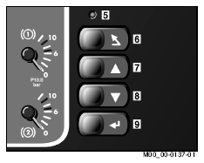

NEVER OPERATE THIS PANEL WHILE THE BUS IS IN MOTION. THE PARK BRAKE MUST BE APPLIED AND THE IGNITION ON

When a warning is displayed the warning can be transferred into the memory field by pressing button (6). If several warnings are pending they are displayed in succession when button (6) is pressed. After all warnings have been displayed they are moved into the memory field.

The warning displays transfer to the memory field (1). The status indicator corresponding to the memory field lights up in yellow or red depending on the severity of the malfunction. In the memory field all pending warning displays are shown in succession.
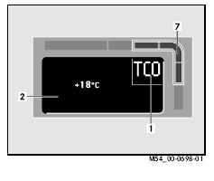

THERE ARE A NUMBER OF OTHER DIAGNOSTIC FUNCTIONS IN THIS SYSTEM WHICH ARE USED BY MAINTENANCE TECHNICIANS TO REPAIR THE BUS – THE DETAILED USE OF THESE MENUS ARE NOT DISCUSSED HERE.

Symbols shown on FIS Display

The following symbols can be shown on the FIS display:

External Temperature

The external temperature is automatically displayed after the functional 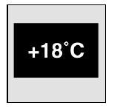 check is complete.

Coolant Level

Is displayed when the coolant level in the cooling system expansion tank has dropped below the minimum capacity.
At the next stop pull over and seek advice. Considerable damage to the engine can occur when the coolant level is too low.



Oil Pressure
If the status indicator immediately lights up red, stop the bus immediately, traffic permitting.

The engine oil pressure warning display is shown in the FIS when the oil
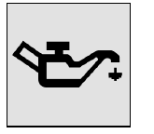

pressure is too low in the engine. Danger – stop the bus immediately, traffic permitting, switch the engine off and seek advice. Significant engine damage can occur if the oil pressure is too low.

Power Steering oil Level

Is displayed when the oil level in the power steering pump has dropped
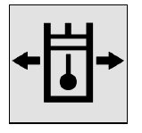

below the minimum capacity. Danger – stop the bus immediately, traffic permitting, switch off the engine and seek advice. There is a risk of accident if there is oil loss and the steering becomes heavy.

Engine protection function information

The engine protection operating information is displayed when the coolant temperature reaches 105 degrees Celcius while the bus is being driven. This may be caused by a number of causes. The engine power will be reduced significantly to protect the engine.


Display failure

 Is displayed when important operating information warnings or events can no
longer be shown on the FIS display. Danger – risk of accident – the bus driving and braking characteristics may change. Stop the bus, traffic permitting and switch off the engine and seek advice.

Brake Circuits 1-2 reservoir pressure

The reservoir pressure in brake circuits 1 or 2 are is under 6.8 bar, which is too low. Danger – stop the bus immediately, traffic permitting and seek advice.


Reservoir pressure auxiliary consumers

Is displayed when the reservoir pressure in the auxiliary consumer circuit drops to under 5.5 bar. This may be caused by an air leak or excessive constant raising and lowering of the suspension and opening and closing doors.
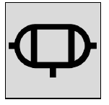

Danger – this indicates malfunctions in the pneumatic suspension
system , door system. Stop the bus seek advice and only drive if the air
system recharges so the display goes out.

Anti Lock Braking System Information

If the display does not go out, or lights up as the bus is being driven, the ABS and the ASR are fully or partially inoperative. Danger – drive the bus carefully and report the fault.
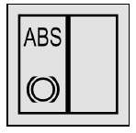

Brake Pad Wear

Is displayed when the brake pad wear is too high on one or more axles. Danger – the bus driving and braking characteristics may alter. Drive with care and report the fault.


Retarder Temperature

This is displayed when the retarder temperature integrated in the automatic gearbox is too high. Danger – when the retarder temperature is too high the effectiveness of the retarder drops.
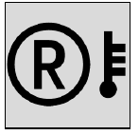

Alternator 1 not charging properly


Is displayed when the charging voltage from the alternator is incorrect. Danger the driving characteristics may change, Stop the bus, traffic permitting, and switch off the engine. Seek advice.

Battery Overcharge

The overcharge warning display is shown if the alternator is overcharging the


batteries. Danger – the driving and braking characteristics may change – stop the bus, traffic permitting and seek advice.

Battery Undervoltage

The under voltage display is shown when the voltage drops below 22 volts.


Danger the bus drivig and braking characteristics may alter – Stop the bus, traffic permitting and switch off the engine

      - Bus suspension levels

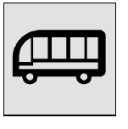 Suspension is at normal level
Suspension is either raised or lowered. Danger drive carefully when the bus is raised or lowered – be careful of overhead clearances and ground clearances.

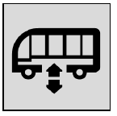

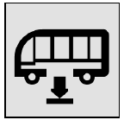

Air Filter Clogged
Suspension is in kneeling position. Danger – risk of entrapment of pedestrians
– make sure persons outside bus do not come between the underside of the bus and the kerb surface. Only use when bus is stationary.

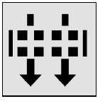 Is displayed when the air filter is clogged.

Door Open

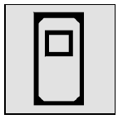 Is displayed if one or more doors are open. Danger – ensure doors are closed.

Stop Request

Is displayed if passenger presses stop button – note there is also a large dashboard light to the right hand side of the steering wheel to warn a passenger has made a stop request.
